Environment, Food & Rural Affairs (EFRA) Committee

Inquiry: Rural tourism in England

The House of Commons Environment, Food and Rural Affairs Committee is carrying out an Inquiry into the role of tourism in supporting rural growth in England.

Rural Tourism provides around £17 billion a year to the English economy. But rural communities face some particular challenges to tourism growth such as transport connections, restrictions to broadband access and seasonal employment.

Although England has seen a rise in tourism spend in the past year from both domestic and international visitors, figures published by Visit England show that in 2014 just 18% of domestic overnight trips were taken to rural areas, down from 22% in 2012. Over 50% of international spend was in London.

Chair's comment

Neil Parish MP, Chair of the EFRA Committee, said:

"Tourism in rural areas creates job opportunities and supports the economic viability of communities. At a time in which volatile agricultural prices and depopulation threaten businesses and rural services, we are asking how effectively public programmes and government policies support these areas to stay competitive in a global industry. We will also be asking how we can work to make the growth of countryside and coastal tourism sustainable, balancing economic, social and environmental interests."

Terms of reference

The inquiry looks into a number of matters relating to supporting rural growth, in particular how government policies can:
- encourage more people, both from the UK and abroad, to visit more of England’s rural places, for longer and at all times of the year;
- support farmers and rural residents to diversify into tourism and grow their businesses;
- ensure visitors' experiences are balanced with the need to preserve the environment and the character of local communities.

The Committee is seeking written evidence on the following key questions:

Marketing: How well do agencies promote rural destinations across England? What more should the Government do to support this work?

In 2006 ten selected mining landscapes across Cornwall and west Devon were inscribed as a UNESCO World Heritage Site, placing Cornish mining heritage on a par with international assets such as the Great Wall of China.

Over £1m has been invested in improving the facilities of partner mining visitor attractions. The project has directly engaged 400 businesses and enabled a sustainable model for attractions and venues. Business engagement has also enabled the alignment of specialist heritage management practices and sustainable tourism to provide a marketing focus for a range of Cornish businesses. Sales of products as a result of WHS status have enabled income generation linked to the WHS brand.

In addition Cornwall Council and its partners have developed the Tin Coast Partnership focusing on the communities between Pendeen and St. Just to keep spending local through jointly utilising infrastructure, rather than the creation of destination facilities that will not add value. Businesses become ambassadors and a resource for their area, which represents not only places working together but also organisations: such as the partnership between Cornwall Council and the National Trust to ensure co-ordinated investment. The WHS destination management plan states the following:

‘The remit is wider than just the visitor economy and the supply chain to the visitor economy. The Partnership will seek to use its influence to conserve cultural heritage and the natural environment, and to improve the local infrastructure and community facilities (e.g. transport, library & information services and public toilets), so far as these have an impact on visitors’.

Devolution of infrastructure to town and parish councils from principle Councils needs to be recognised in the context that these assets are part of the marketing tools for a community and need to be integrated into its ‘story’. St.Ives library, for example, is predominantly used by summer visitors seeking Wi-Fi. It is important that organisations taking over devolved public toilets can do so without unnecessary bureaucratic costs.

Cultural change is also needed, so that businesses offer the use of toilets without the expectation of patronage; perhaps by encouraging a voluntary contribution in return to help support the maintenance of tourism assets.

Cornwall Council has also transferred its tourism support – Visit Cornwall – into a Community Interest Company partnership with business. Most of its income comes from coastal tourism businesses and farms. Effective tourism businesses need to be strongly related to the landscape that they operate in and reflect natural capital in the supply chain. Although city breaks have increased in popularity as a brand, coastal areas have become a destination; there needs to be strong integration between facilities to cement an ‘offer’.

SMEs need to be able to market through content upload expertise. This needs support, particularly for micros, and the reach of broadband to the ‘last 5%’. Training and support is also needed as Government moves interaction onto the internet. Tourists want a unique experience through micro businesses therefore niche marketing becomes more important. Broadband is also an expectation of the visitor experience and can support interpretation and the public value of assets.

Access: What, if any, changes are needed to give people better access to the coast and countryside?

Connectivity is an important principle to ensure that transport infrastructure in rural areas works to maximise investment and encourage the visitor to experience those parts of an area that they would not normally visit.

Issues include the opportunity of devolution. Cornwall Council, the first rural/unitary devolution area in the country will have the power to direct and configure integrated public transport by 2018. Potentially a more effective way of enabling countryside access as it allows greater integration between bus and rail services to provide more effective transport solutions., which would also bring benefits to the existing rural community.

Cost effective means of accessing the most rural areas without a car remain a challenge for rural local authorities as the level of demand and distances involved make it near impossible to run services without subsidy or the goodwill of voluntary organisations.

Cornwall Council is developing a network of cycle routes. There is an imperative that these are joined up and safe; ensuring safety within the transport network is cheaper than the cost to the economy of death and injury. Alongside this, schemes such as ‘Bay to Bay’ in Mounts Bay will enable visitors to hire bikes and use the dedicated cycle routes to explore the area.

New technology also offers the opportunity of tourism from wherever you are and/or if the individual has a physical disability. The Sensory Trust, for example, has developed such an approach with King Edward Mine (a WHS project) through its partnership with the Trust has 20% disabled visitors. The evolution of the Clay Trails through LEADER in the 1990s/2000s is another good example..:

In addition, Visit Cornwall is bidding to Visit England to develop a tool that can personalise itineraries linked to themes such as interest or access.

Issues include:
- The natural, historic and built environment presents challenges for universal access. If not practically achievable, do we always do all that we can to ensure as broad access as possible – in terms of disability, affordability, age, and in the use of information, language and interpretation? The lack of evidence suggests that more work is required to understand the current position and the opportunities to deliver the extraordinary. Local government needs resources to support evidence development: there are potentially conflicting issues between access and aesthetics.

- The ability for comprehensive positive action for environmental sustainability is also an inclusion issue. This might be through access and ability to re-use, recycle, access energy-saving and home improvement initiatives, reduce food miles and protect natural habitats. There are issues of affordability of local food verses economic pressures on the farmer. Energy saving measures require finance to support their installation.

Local authority funding pressures mean that Cornwall Council will need to prioritise road maintenance in the future. Rural and minor roads (and footpaths) could increasingly lose out; yet these are vital links for the rural and coastal economy. There is a tipping point from programming and funding planned work to reactive maintenance.
The British Hospitality Association 2016 report, ‘creating coastal powerhouses’, noted that a range of deprivation indicators are more likely to be features of the lives of people who live on the coast.

Transport connectivity is important: record tourism numbers leads to road congestion and accidents. The increased capacity of Cornwall Newquay Airport needs to be preserved and extended at Gatwick through second runway delivery.

Rail franchise responses need to consider their impact on the tourism and wider business economy; in addition, single track throughout the south west limits the number of services that can be delivered. The long term future of the line at Dawlish remains a maintenance cost issue in the light of climate change and severe weather.

Encouraging ‘car fee days’ has been a successful approach in Cornwall: tourists who have arrived by car are encouraged to enjoy the region without its use including cycle rides on the Camel trail, a branch line train trip, an open bus top tour of west Cornwall or a walk on the coast path. Education and information for visitors on such opportunities and experiences are needed: there is the potential for package holidays to operate in such a way.

‘Access’ is an important principle for all as it is the basis for the individual to understand their part in the impact of resource consumption and also as a basis of ensuring physical and mental health which can save the NHS over £2b per annum. It can also provide understanding and patronage of local food and drink products. Ideally, Cornish communities need the tools to be able to monitor this access and its impact. Employers and NHS need to be aware of the opportunity that the natural environment can provide.

Funding and fiscal policies: How can public funding be best targeted to get new rural tourist businesses off the ground and keep them going? Are changes needed to tax levels and business rates?

One of the key issues for UK farmers is the nature of the future trading relationship with the EU. The nature of EU tariffs and UK protection targets will be critical if trade deals are not reached before Brexit becomes a reality.

The Common Agricultural Policy includes both the Basic Payment and Rural Development funds used for, amongst other things, agri-environment schemes. Outside the EU there would need to be a British Agricultural Policy; there may be regional implications with further devolution which could assist local markets.

During the EU referendum campaign the Brexit side promised that direct payments would be kept at current levels; however this non-binding commitment is only up to 2020. There is a threat in the short term that subsidies could be eroded which may affect farmers as guardians of the countryside and wider environment.

It is important that farming is given the opportunity and support to diversify. This will help support the sustainability of rural communities. An excellent example is the agri food project in east Cornwall (Norton Barton) where investors are opening up redundant farm buildings for micro manufacturing of Cornish brand products: incubation can then grow into larger premises in nearby towns.

Brexit means that there needs to be renewed consideration given to the role of farming both within the environmental and economic context of the UK. Farm gate prices are continuing to decline and issues include cash flow with purchasers (supermarkets). Big cropping producers have also seen substantial drops in income. Brexit also has implications for per acre support for fallow environmental schemes which needs to be balanced against the UK Government opportunity to support flood risk areas with environmental mitigation schemes. Farmers are crucial to maintaining the environment and food security.

These issues affect both the supply chain and the individual health of farmers and their families with a knock on effect on the public service purse.

In perspective, Cornwall produces £1b of milk per annum; so a drop of a penny in price equals a loss of £10m to the local economy. The latest national GDP figures show overall economic growth overall, but a fall of 0.4% in agriculture.

Some farmers will use land as collateral against bank loans. This is where artificial value has been hiked in an era of low interest rates and investors looking for alternative investments. Land is also a safe haven from inheritance tax and corporate and individual investors are using it as an investment.

Cash flow for farming, then, is a significant issue which puts a strain on suppliers and limits scope for diversification of the rural economy. The Princes Countryside Fund commissioned the Anderson’s Centre in March 2016 to create a snapshot of farm cash flow pressures. This includes:
- Continuing decline in farm gate prices
- Farms making a loss even with the input of family labour and capital
- Farming is not the only activity that helps to sustain income
- Levels of borrowing have almost doubled in the last decade
- Issues around the ability to pay off short term debt: credit with suppliers
- This is also affecting businesses such as vets, input suppliers, auctioneers
- Basic Payments were being delayed for half the sample

The facilitation of good communication between businesses and reduction in bureaucracy is important. Strong emotional intelligence also needs to be developed to assist working communities impacted by economic challenges. Farm managers also need stronger business orientated skills. In both respects sustainable funding of organisations such as Farm Cornwall is crucial.

Research by the Anderson’s Centre indicated that 60% of their south west sample was experiencing cash flow issues. Those who farm in sensitive landscapes rightly have additional cost pressures and limitations on changes to productivity models, but there should be support to reflect this.

Overall, uncertainty over the future of EU funding during this period of Convergence to the early 2020s; lack of clarification following the Brexit promises of the rural economy not losing out and delays to the implementation of Community Led Economic Development will not help the opportunity for management and diversification of the rural economy.

Businesses still developing their funding strategy for EU funds which may not be ‘oven ready’ by the autumn statement, having the confidence to match invest and revenue costs need to be addressed once capital projects have been completed.

While some respondents may bemoan a lack of support for tourism from their LEP it is important to note that the Cornwall and Isles of Scilly LEP Strategic Economic Plan recognises the connectivity of tourism to other parts of the economy and its subsequent importance.

There is little sense in VAT being charged on the full value of restoring a building whereas there is a reduced rate for building a new one.

Coastal, and wider, tourism is disadvantaged when 31 other European countries currently benefit from a reduced level of VAT which enables them to channel investment into business development. France for example only has a 5.5% VAT levy on accommodation and dining.

Any loss in VAT to the Treasury would be offset by tax gains from employment and subsequent reduction in benefit payment; as well as a positive impact on the tourism business supply chain and freedom to spend revenue on local public services that support tourism and other sectors. The current threshold makes it difficult for businesses to support an all-round offer, which in turn impacts on sustainability of employment, retention of skills and the wider economy of communities.

The international tourism market is a competitive one, likely to increase for the UK if Brexit adds bureaucratic pressures to free movement.

When Cornwall has bumper tourism season, there is pressure on public services and the emergency services at a cost to the local public purse which is not reimbursed. 31% of visitor spend (£600m) goes to central government.

Planning and regulation: What, if any, changes are needed to planning and other regulations covering rural areas of special character, such as National Parks, to encourage sustainable tourism?

Cornwall has a number of areas of special character including the WHS, the AONB and SSSIs. The map below shows these in totality and gives a flavour of the sensitive Cornwall landscape for tourism, the dots are ancient monuments:

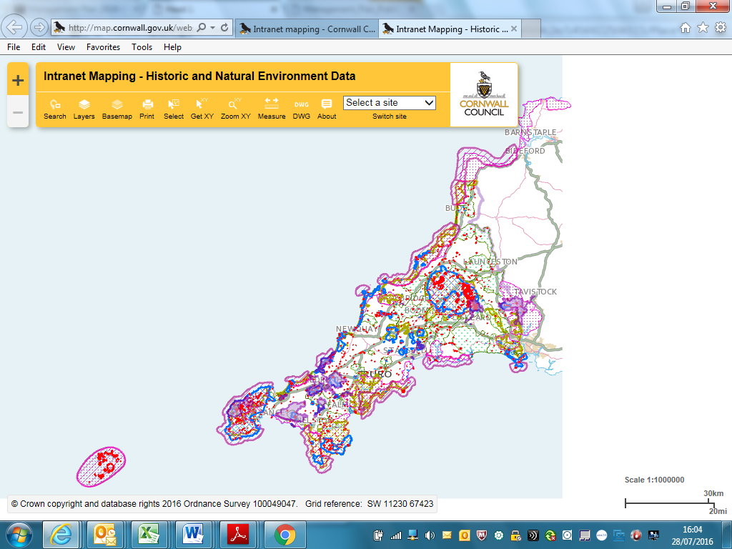

Cornwall Council welcomed the importance that DEFRA and the Government gave to the rural economy through the Rural Productivity Plan and would remind the inquiry of the Rural Planning Review of April 2016. Evidence submitted referred DCLG and DEFRA of the importance of the agricultural economy and the significant manufacturing and cultural contribution to the economy.

Permitted development rights need to enable ease of farm buildings conversion to other appropriate economic activity which provides residents with somewhere to work and space for business to grow. At the very least, micro space can provide an opportunity for collaboration.

In some areas buildings with historic and/or aesthetic merit can be sensitively converted to useful purpose which can also: secure their survival and maintenance and be more appropriate to setting. Bodies such as Natural England and English Heritage can block development based on the application of national policy with less appreciation of local context.

Ideally, rural planning applications should be based on wider criteria such as how a development can sustain an all year round economy. This could be supported by planning obligation requirements for infrastructure integration and/or the preservation/promotion of the natural environment which is part of the Cornish brand. Particularly for tourism, there is a need to provide funding opportunities to support revenue funding and updating of projects to ensure that initial public investment is not ‘wasted’.

Supporting heritage skills and continuous development is important in a local authority such as Cornwall and includes planning and enforcement capacity. Heritage Lottery support needs to be understood in the context of a diaspora of six million people internationally, a similar number visiting the region each year and yet only a population (if per capita funding is considered) of just over 500,000.

A series of reports commissioned by Government over the last decade recommended that problems in the planning system should be addressed through monitoring and appropriate sanction. However, with regard to heritage these would need to be carefully applied to avoid negative or unforeseen consequences such as discouraging ownership or maintenance of heritage. All of these reports (Barker, Killian Pretty, Penfold, Lyons) recommended against higher fees.

Utility and transport companies should be required to consult and co-ordinate with local authorities to ensure that disruption is minimised; failing that the local authority can impose higher than token fines on violation.

Infrastructure and skills: What measures are needed to ensure transport, housing and other infrastructure meets visitor needs? How can the sector ensure there are enough people with the right skills to support customers and businesses?

For farming aging infrastructure, funded through grants made in the 1970s and 1980s, can be a drain and pressure on farm incomes/sustainable farming. There is a need for new infrastructure to be financed. The feed in tariff, now reduced, provided an income for some

The obvious infrastructure issue is securing usable broadband for the last 5% of rural areas.

Green infrastructure and biodiversity corridors need to connect physical infrastructure with ‘green’ features integrated into design. This provides the basis for good physical and mental health.

Local environment and character: How can national and local policies get the right balance between growing tourism and enhancing the local environment and character?
Cornwall’s tourism strategy is based on the product of its character and natural capital, which informs the Cornish brand and business success.

Further, ‘depopulation’ is not an issue affecting Cornwall. Its population is forecast to double from the 1970s to around 620,000 by 2030. The issue is one of sustainability and the growth of natural capital to service this growth, together with an aging population and associated health challenges/NHS capacity; as well as the capacity of infrastructure and public services to cope with tourism spikes/general growth of population. Ensuring that public services in Cornwall are fairly funded is a necessity.

Through designations such as the AONB and WHS Cornwall has been able to develop projects and a brand valued by the visitors and residents alike; embedded in a living community. Overall, the downside has been infrastructure pressure of a growing numbers of tourists (either ‘staycators’ or foreign visitors seeking non London experiences and a safer holiday).

Connectivity is a big issue. The need to complete upgrading of the A30, trunk road safety/design, intrusion into the visible environment of the AONB and the viability/capacity of public transport within and between rural areas requires both local management and flexibility, and cultural change amongst parts of the tourist market.

Regarding the issue of local housing and access, the Committee could consider the St.Ives Neighbourhood Plan which recognises the attractiveness of the town but also the difficulties that local people have in terms of accessing a home; and therefore proposes some restrictions on second home ownership.

Defra role: What more should the Department for Environment, Food and Rural Affairs do to ensure government departments (including Departments for Communities and Local Government, Business, Innovation and Skills, Culture Media and Sport and HM Treasury) support rural tourism?

It is important that funding strategies are better co-ordinated across Government departments. This view is supported by the British Hospitality Association with regard to coastal communities. It is not clear which Department will be responsible for taking forward the recommendations of the inquiry.

The EU supports stewardship funding but there is concern that such money will be used elsewhere se if not ‘replaced’ by the UK Government (i.e. other infrastructure). In some rural areas agriculture and tourism represents almost 90% of local employment and GVA. There is an interconnected relationship between the two; with agricultural businesses relying on tourism income to support revenue, and agriculture managing the rural environment so vital for tourism. Tourism represents 9.9% of Cornwall GVA (2013) and 36,000 direct jobs (Visit Cornwall, 2014).

It is essential that enthusiasm for public participation in the governance of Leader and Community Led Economic Development schemes is not lost following Brexit, and that delay is avoided in terms of businesses considering bids that have already spent early development time and resource. The loss of central and local government funding for tourism means that rural tourism development, which is not as high profile and well-funded as city based tourism marketing,) is dependent on grant funding such as the Coastal Communities Fund or Leader. This challenge is further compounded by the fact that people are taking shorter breaks however this opportunity fits with the cultural profile of Cornwall and the need to manage and spread footfall and further develop Cornwall’s established ‘global brand’.

Additionally, an important principle is to have longer funding initiative response timescales which are flagged up before detailed criteria becomes available. Particularly, broad tourism related initiatives should avoid peak times of the year when the industry is at its busiest. For relatively small amounts of money the application process needs to be simpler to ensure that seed corn money for good business ideas is processed quickly and efficiently and where possible the process is devolved.

